SSIS
TASK 5:
DIM_ARTIST
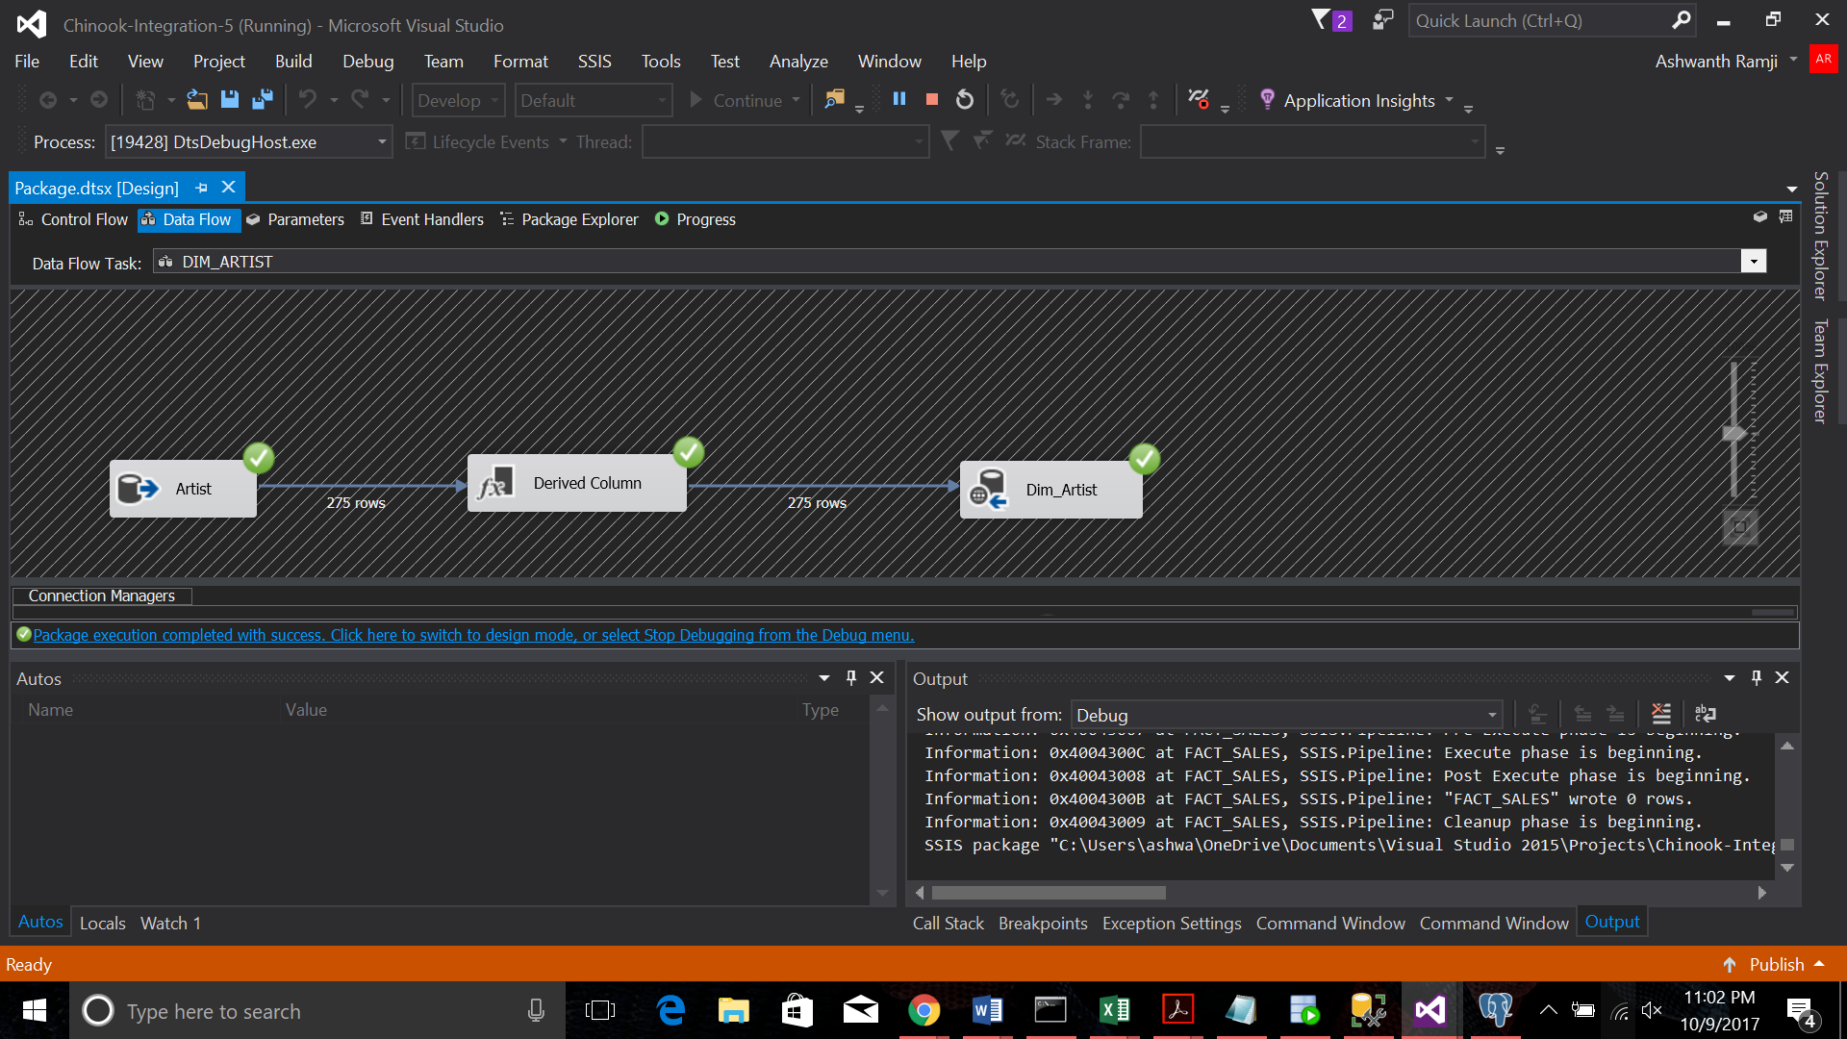
DIM_COMPOSER
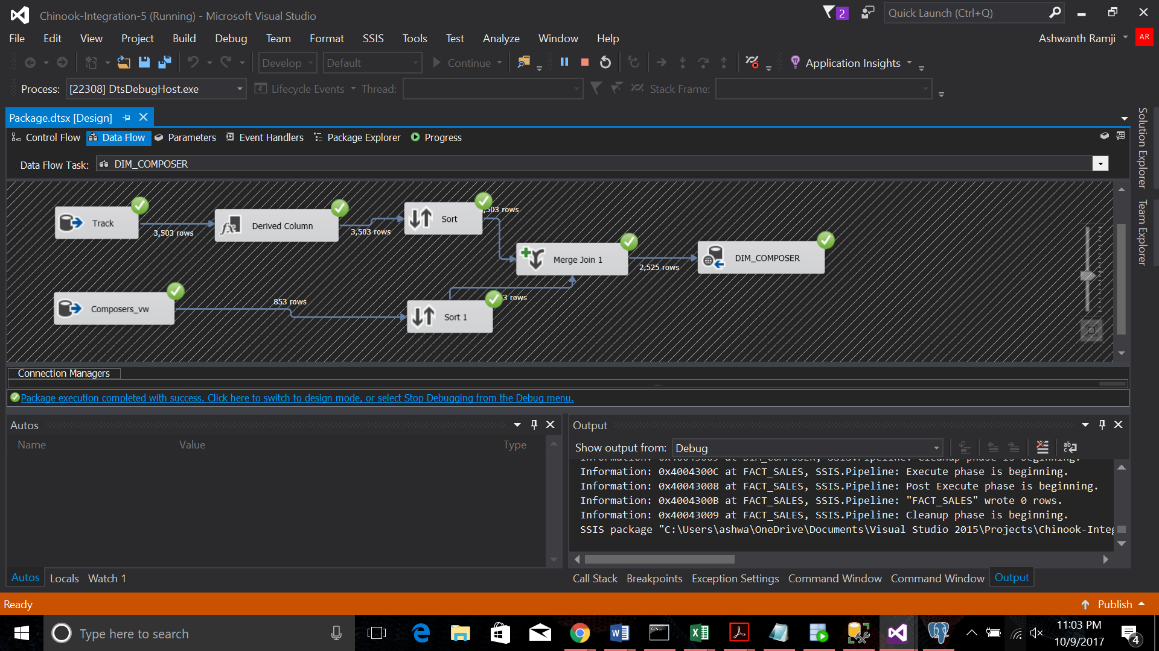

DIM_GEOGRAPHY
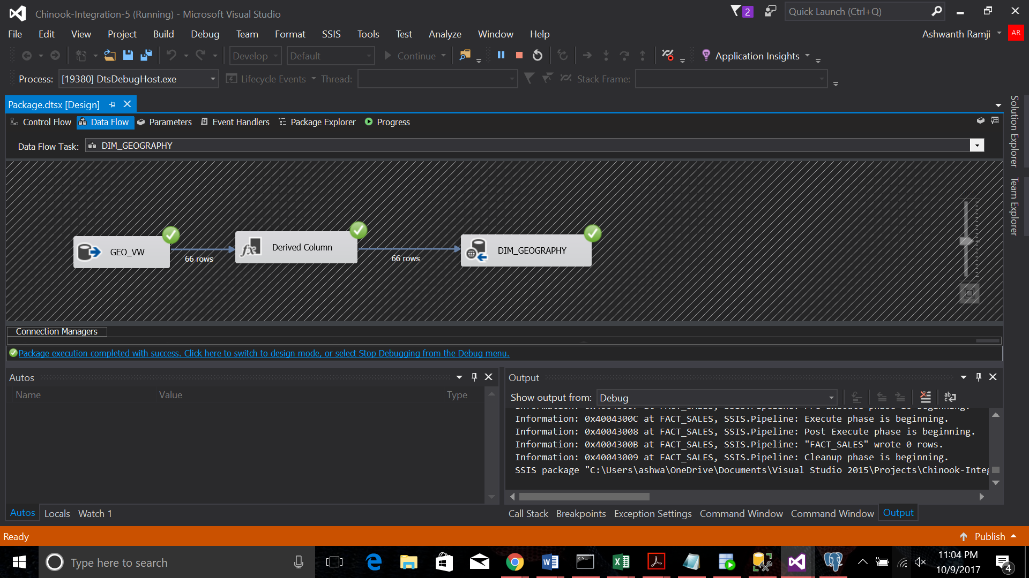
DIM_DATE
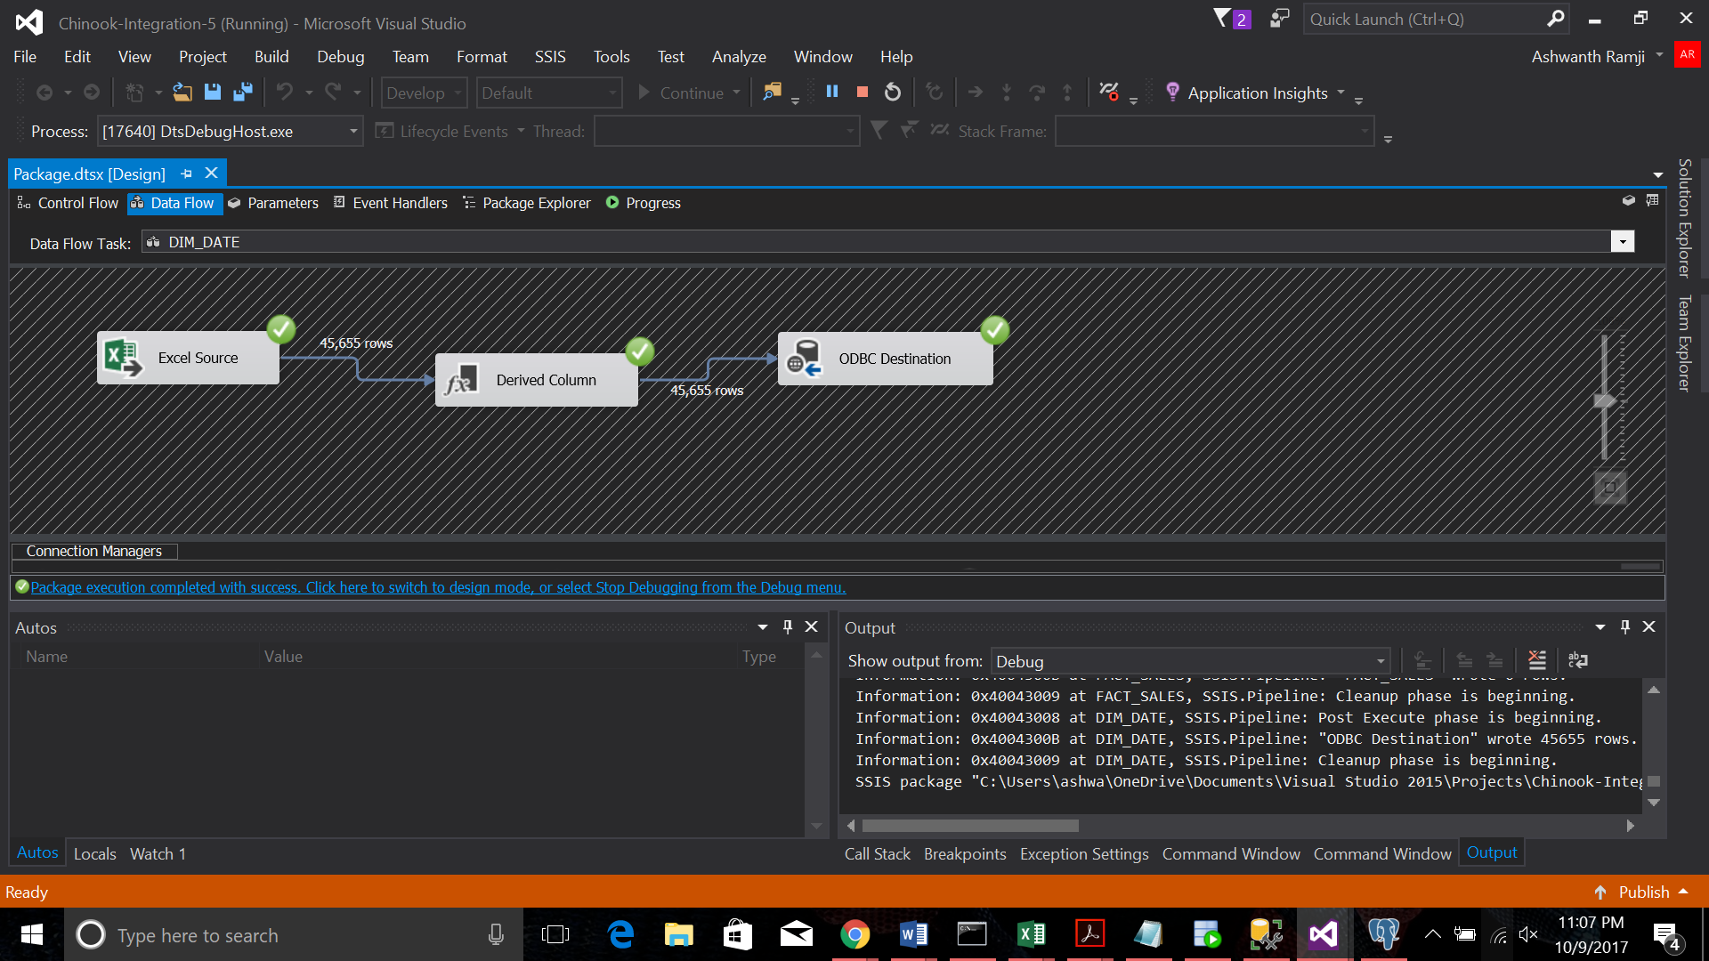
DIM_CUSTOMER
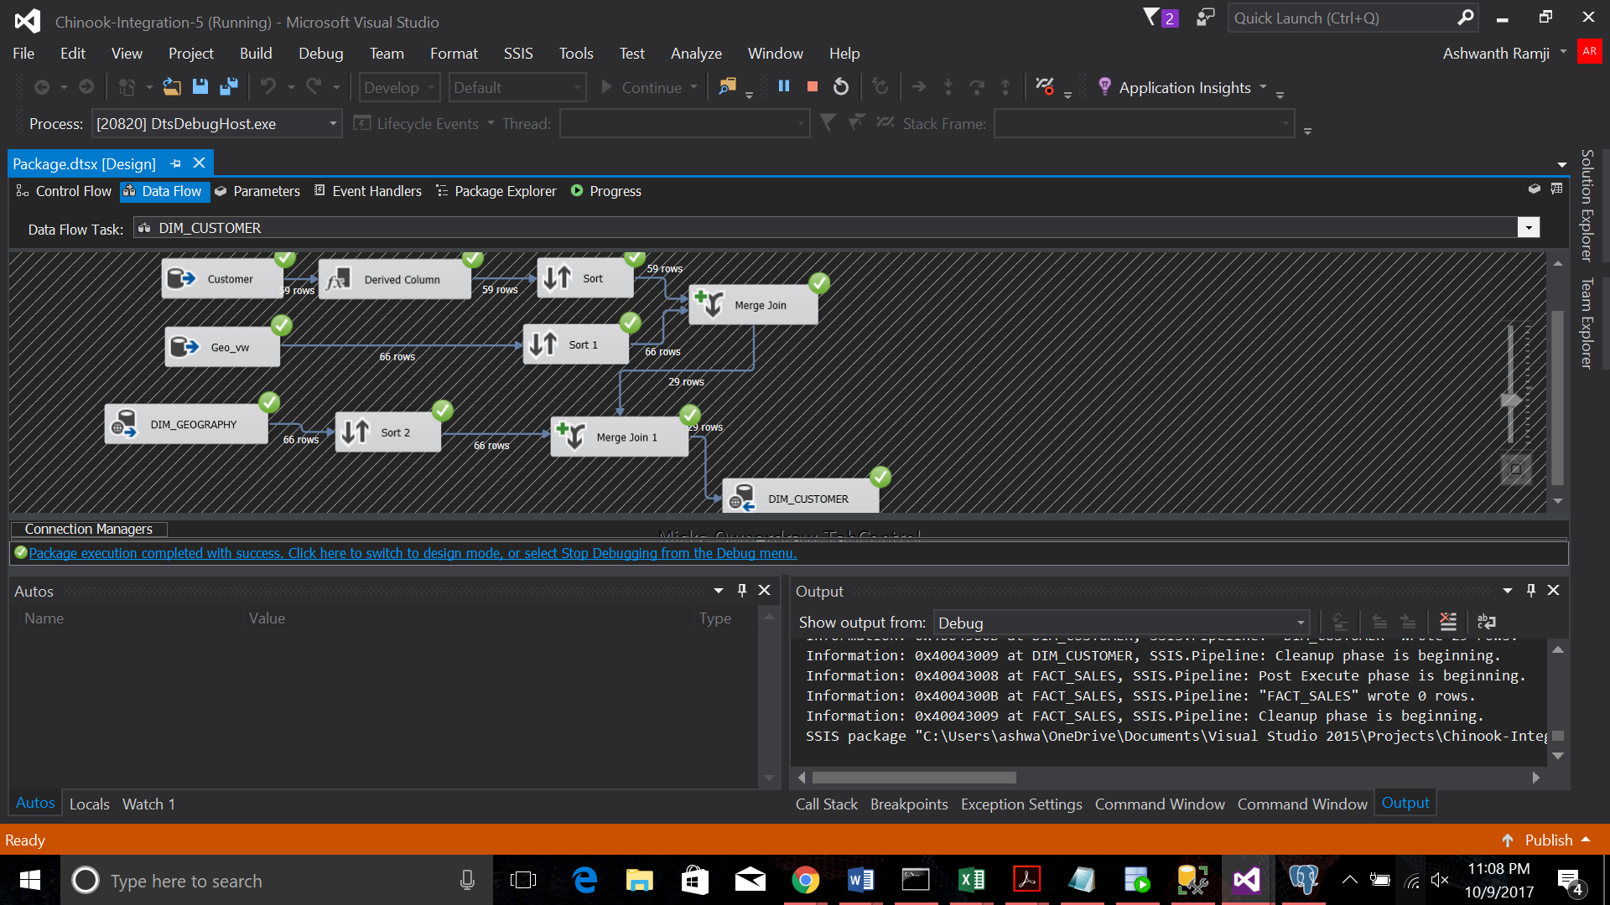
DIM_EMPLOYEE
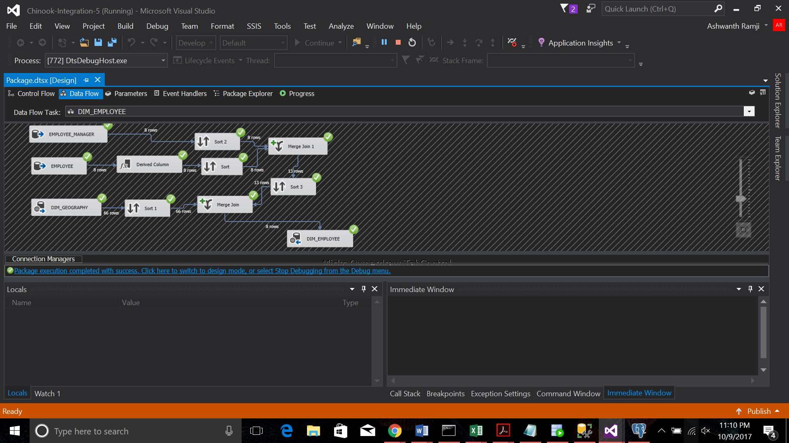
DIM_SONG
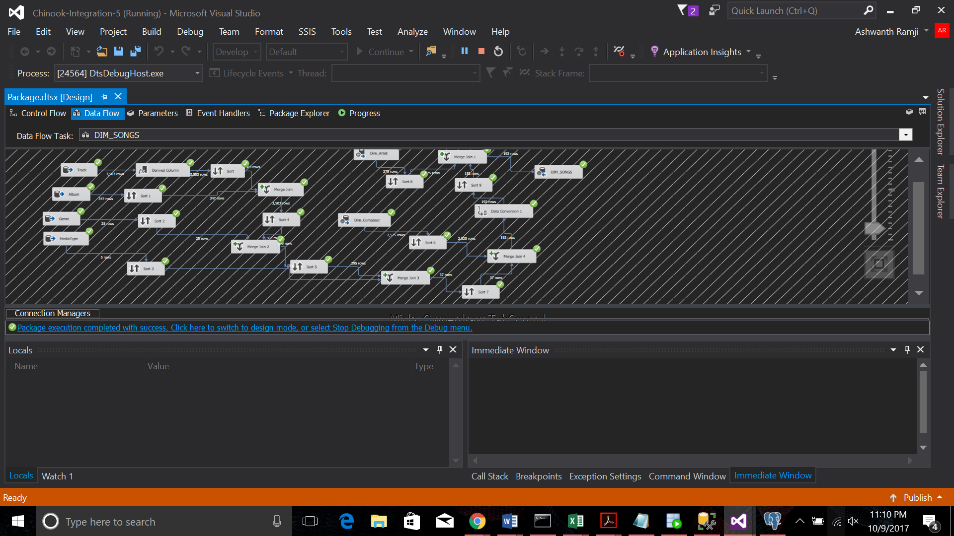
DIM_PLAYLIST
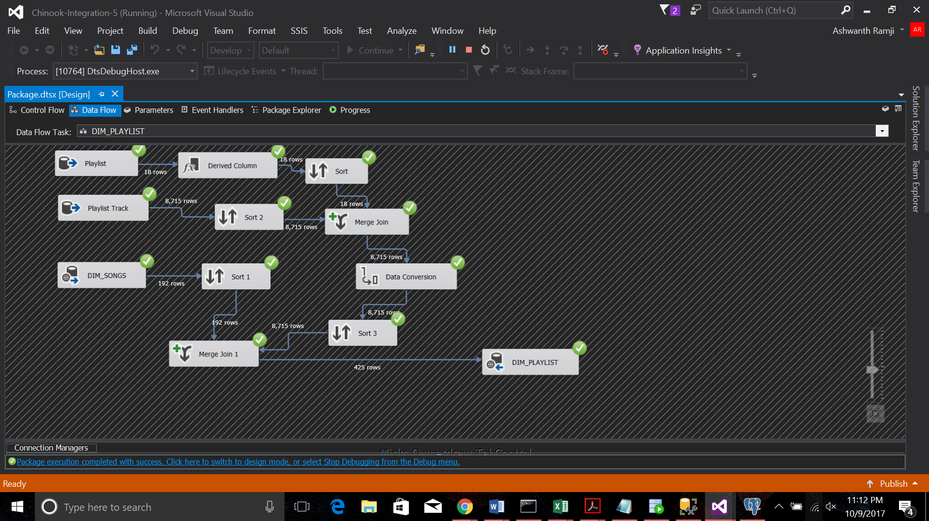
FACT_SALES
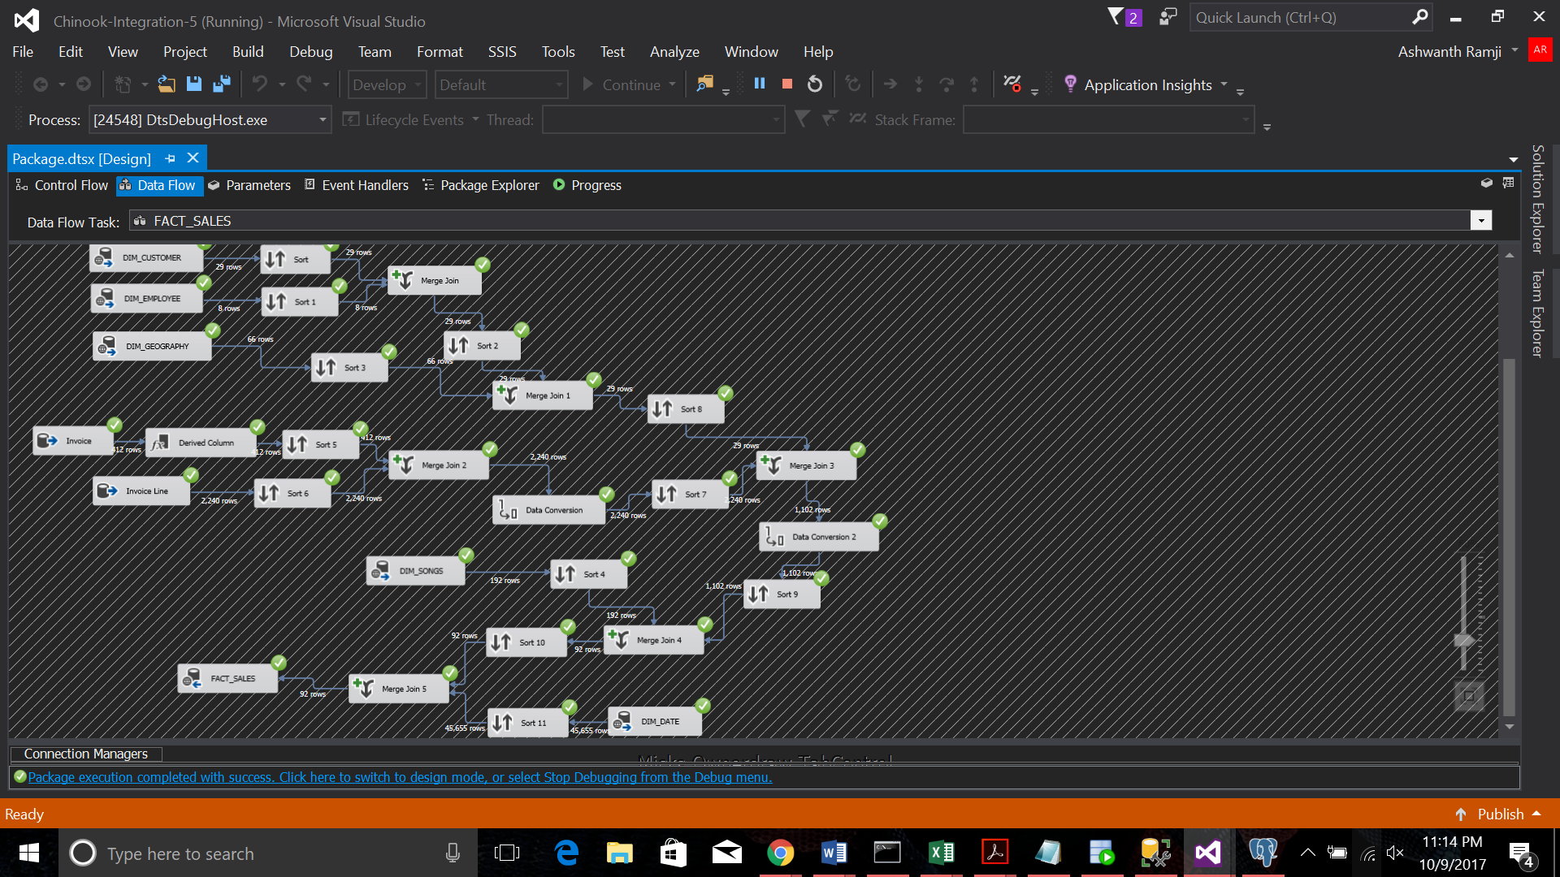

TASK 7
DIM_ARTIST
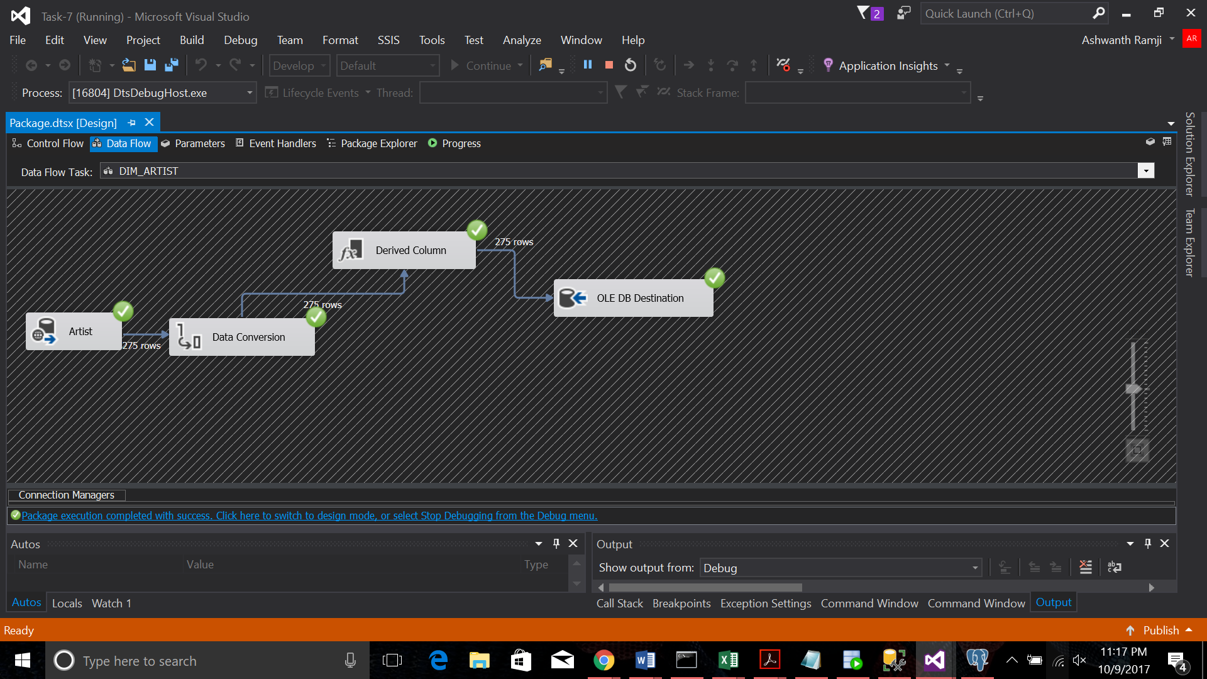
DIM_COMPOSER
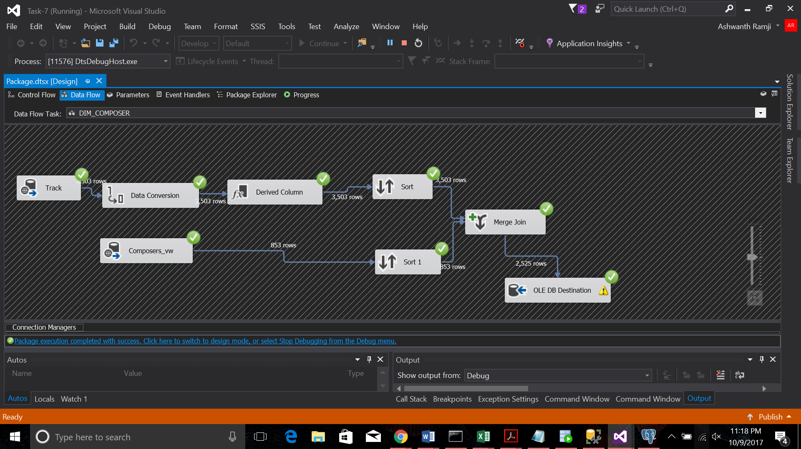
DIM_DATE
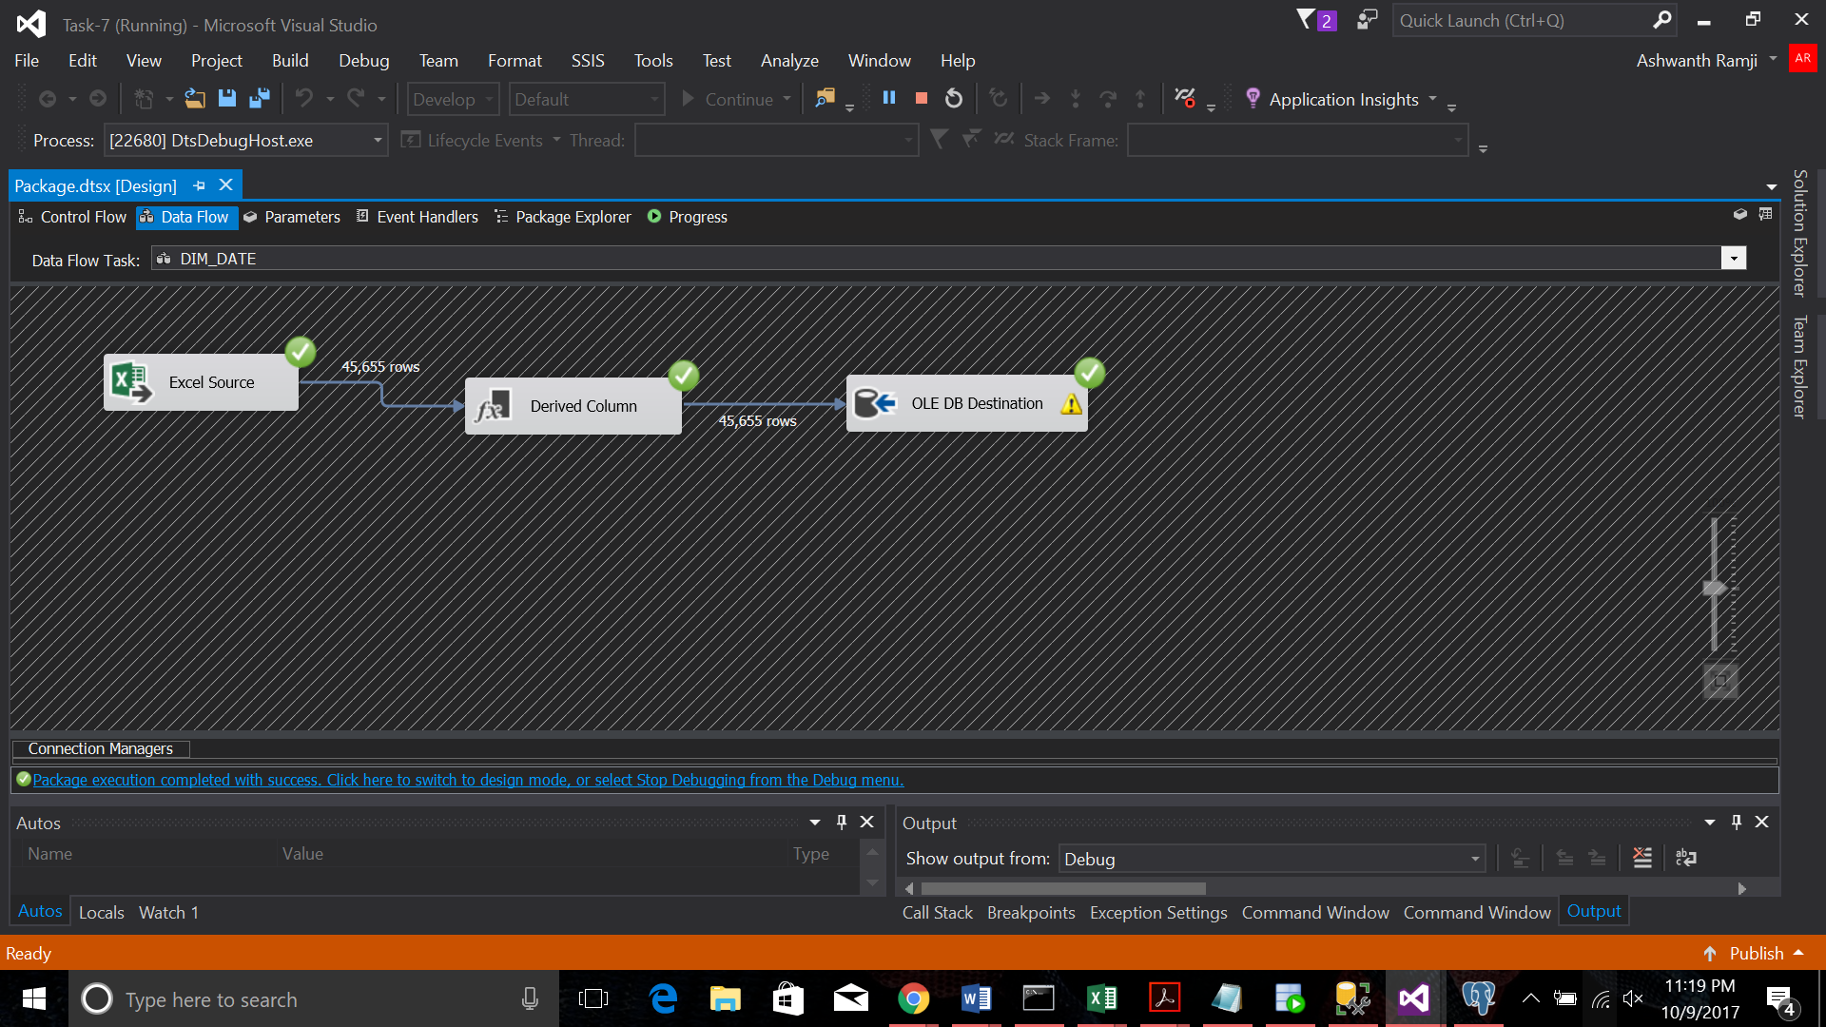
DIM_GEOGRAPHY
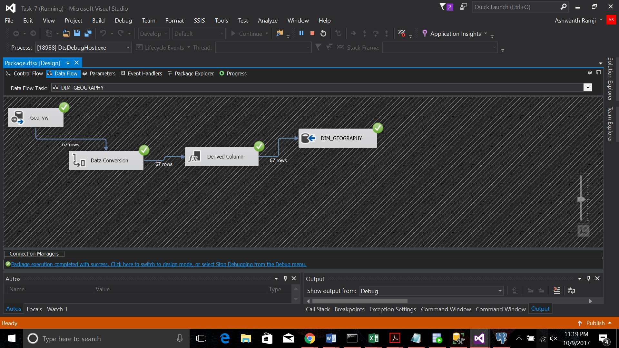
DIM_CUSTOMER
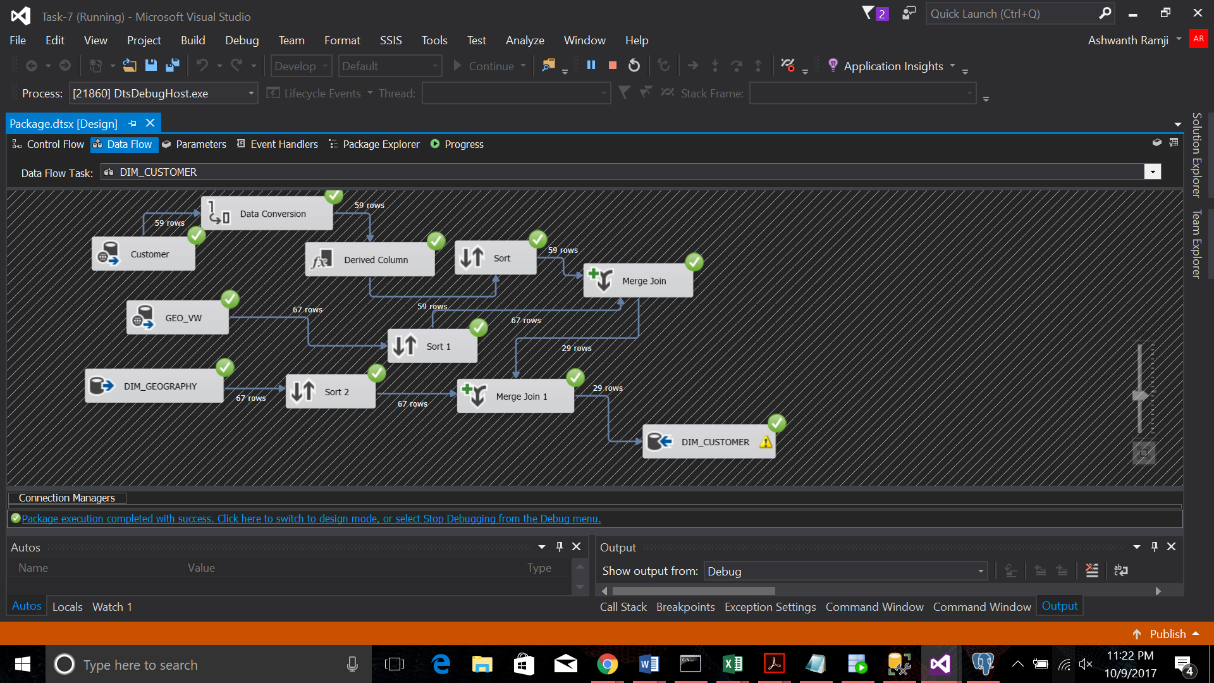
DIM_EMPLOYEE
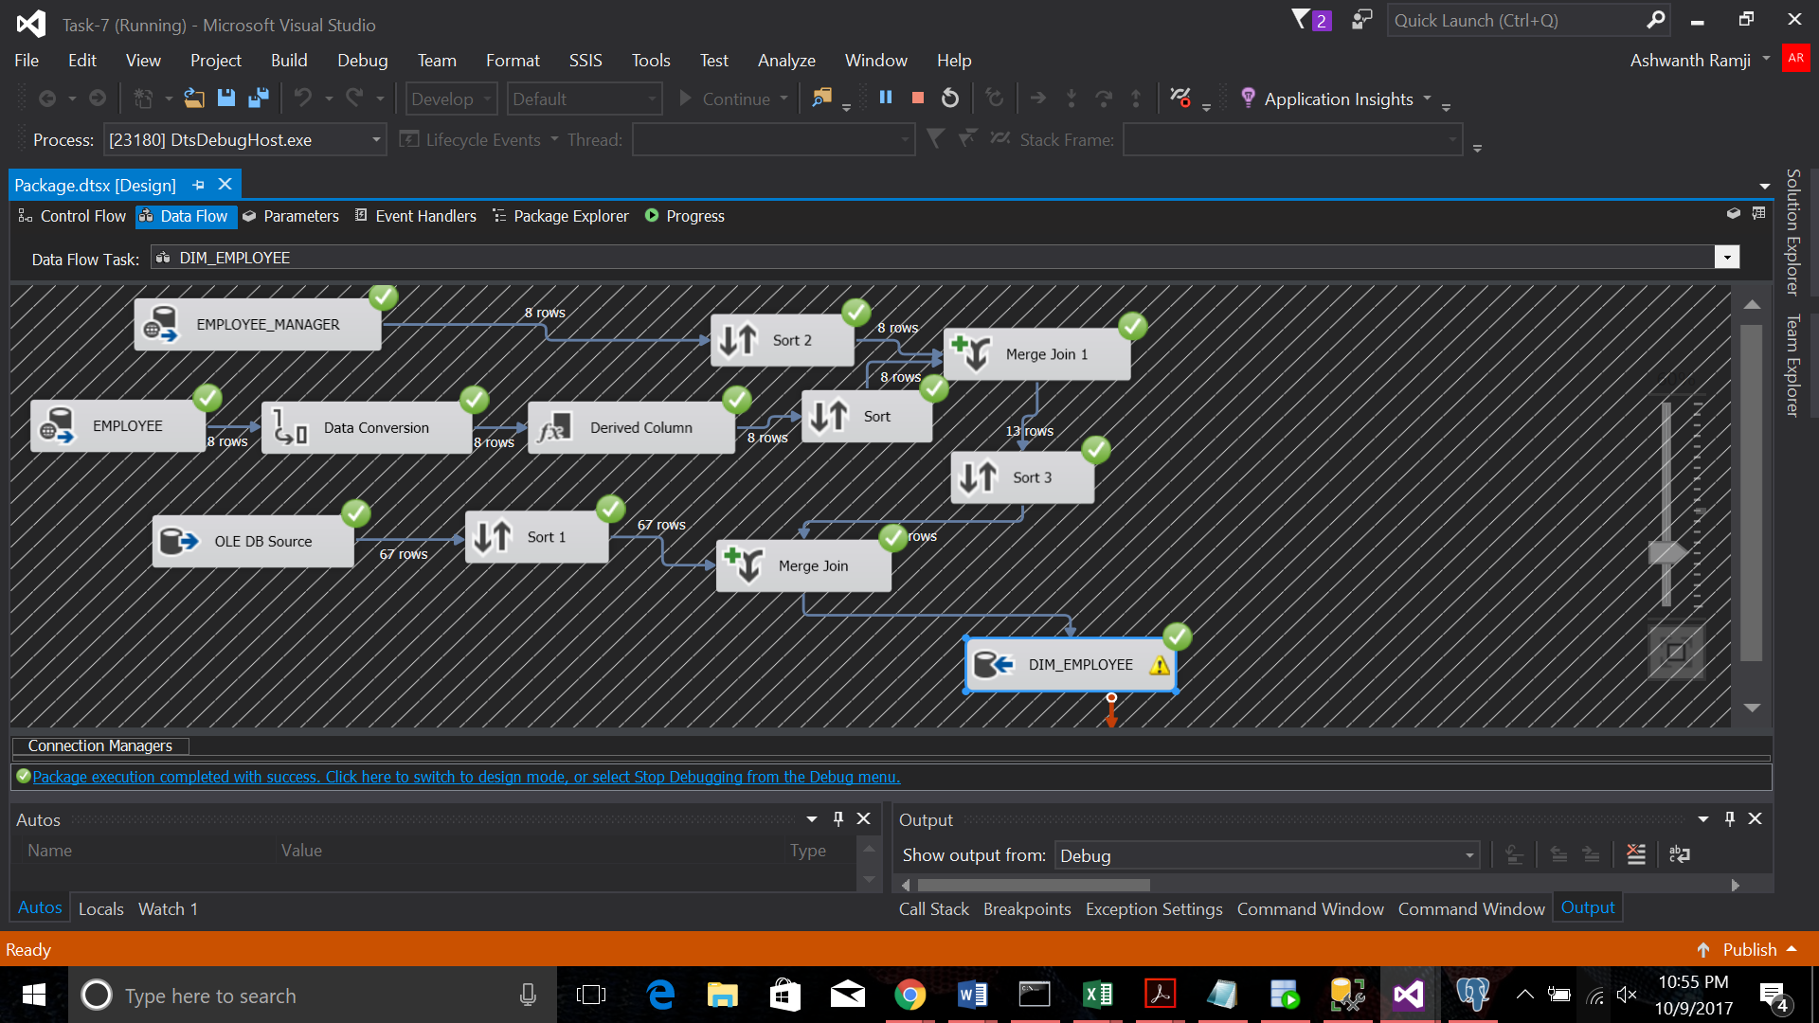
DIM_SONGS
DIM_PLAYLIST

FACT_SALES

TASK 6:
DIM_ARTIST
DIM_COMPOSER

DIM_GEOGRAPHY
DIM_DATE
DIM_CUSTOMER
DIM_EMPLOYEE
DIM_SONG
DIM_PLAYLIST

FACT_SALES
TASK 8
DIM_ARTIST
DIM_COMPOSER
DIM_DATE
DIM_GEOGRAPHY
DIM_CUSTOMER
DIM_EMPLOYEE
DIM_SONGS
DIM_PLAYLIST

FACT_SALES

